**Agenda Item: 1/01**

**= application site**

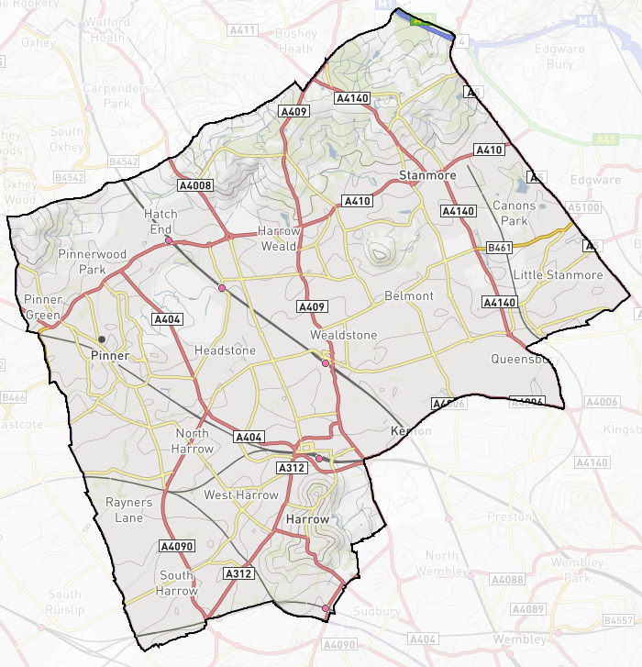

|  |  |
| --- | --- |
| **Waxwell Lane Car Park, Waxwell Lane, Pinner** | **P/1304/20** |

**LOCATION PLAN**

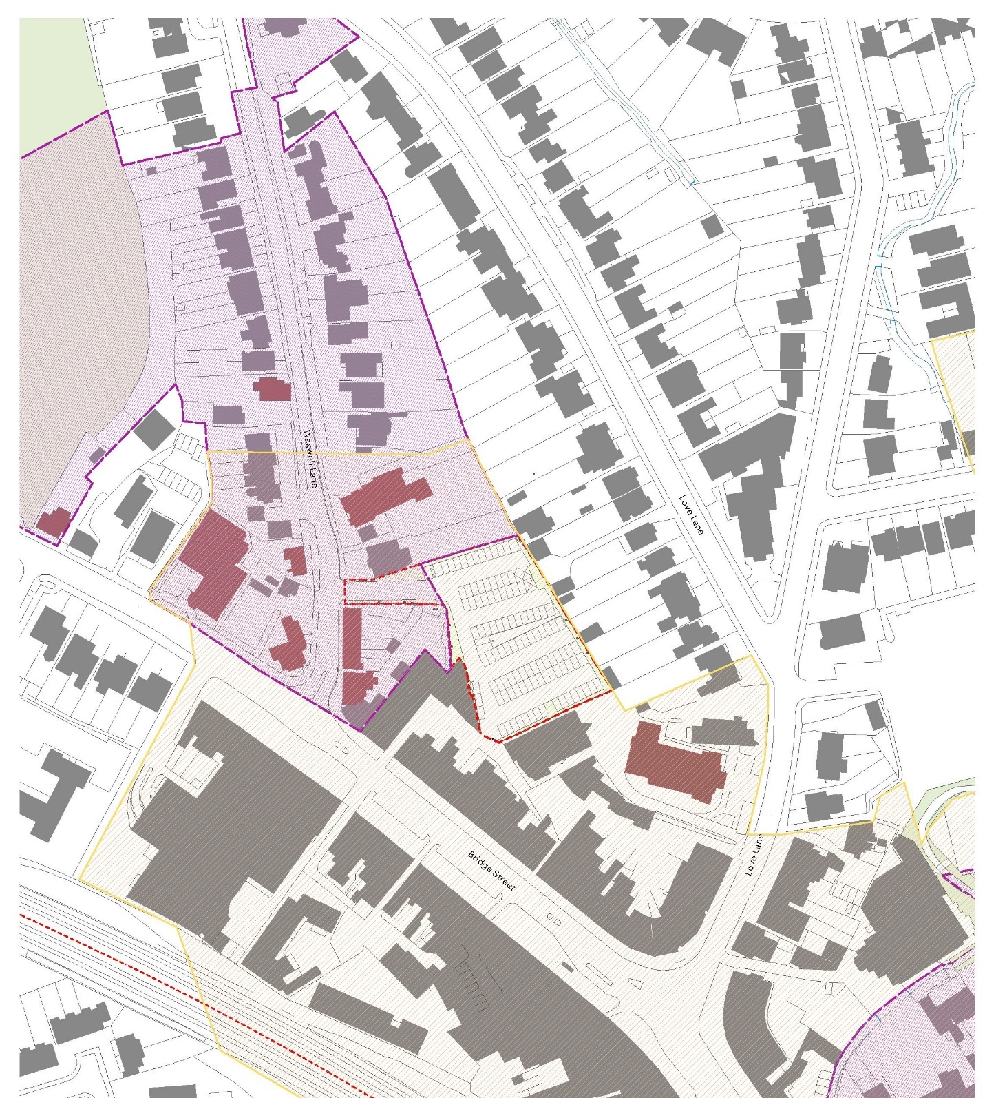

**LONDON BOROUGH OF HARROW**

**PLANNING COMMITTEE**

**18TH JANUARY 2023**

|  |  |
| --- | --- |
| **APPLICATION NUMBER**: | P/1304/20 |
| **VALIDATION DATE:** | 26/05/2020 |
| **LOCATION:** | WAXWELL LANE CAR PARK, WAXWELL LANE, PINNER  (PINNORA MEWS) |
| **WARD:** | PINNER |
| **POSTCODE:** | N/A |
| **APPLICANT**: | HARROW COUNCIL |
| **AGENT:** | N/A |
| **CASE OFFICER:** | KIMRY SCHLACTER |
| **EXPIRY DATE:** | 25/08/2020 |

**PROPOSAL**

Variation of condition 27 (affordable housing and financial viability review mechanism) attached to planning permission P/5680/17 dated 14/06/2018 to allow a change to the timing for submission of the details to the condition from pre-commencement to 80% occupation.

The Planning Committee is asked to:

**RECOMMENDATION A**

1. Agree the reasons for approval as set out in this report.
2. Grant planning permission subject to the Conditions listed in Appendix 1 of this report.

It is recommended that the decision notice is split in two parts in a format similar to the conditions at the end of this report i.e. conditions marked with a single asterix (*) are conditions that will always be binding through the decision notice and conditions marked with a double asterix (**) includes conditions that would be replaced by a legal agreement, were the land owner to have the legal locus to enter into the legal agreement. Condition 28 specifically refers to this approach.

**REASON FOR THE RECOMMENDATIONS**

The proposal would be a more appropriate timing for the condition, as some of the necessary information would not be obtainable until close to practical completion of the project. The application falls under Regulation 3 of the Town and Country Planning General Regulations 1992.

**INFORMATION**

This application is reported to Planning Committee as the development concerns a Council-owned property and therefore falls outside Schedule 1 of the Scheme of Delegation.

|  |  |
| --- | --- |
| Statutory Return Type: | Major Development |
| Council Interest: | Council-owned |
| Net additional Floorspace: | none |
| GLA Community Infrastructure Levy (CIL) Contribution (provisional) : | N/A |
| Local CIL requirement: | N/A |

**HUMAN RIGHTS ACT**

The provisions of the Human Rights Act 1998 have been taken into account in the processing of the application and the preparation of this report.

**EQUALITIES**

In determining this planning application, the Council has regard to its equalities obligations including its obligations under section 149 of the Equality Act 2010.

For the purposes of this application there are no adverse equalities issues.

**S17 CRIME & DISORDER ACT**

Policy D11 of The London Plan (2021) and Policy DM1 of the Development Management Polices Local Plan require all new developments to have regard to safety and the measures to reduce crime in the design of development proposal. It is considered that the development does not adversely affect crime risk.

1. **SITE DESCRIPTION**

1.1 The application site comprises a 0.34 hectare parcel of land located within the Pinner Town Centre boundary and is bounded by Waxwell Lane to the west, Love Lane to the east and Bridge Street to the south.

1.2 The site is currently under development for the permission granted under ref: P/5680/17 and near completion. The street address for the development is to be Pinnora Mews.

1.3 The surrounding area comprises a mix of residentail and commercial uses.

1. **PROPOSAL**

2.1 Permission has been granted (P/5680/17) for the redevelopment of a car park to provide 20 three storey dwellinghouses and associated works.

2.2 The permission included a condition (Condition 27) requiring the submission of a Scheme for details of the affordable housing provided on site and the Financial Viability Review Mechanism.

2.3 The proposal is to vary the timing of the condition so that the information is required at a point of 80% occupancy of the site, rather than prior to commencement.

**3.0 RELEVANT PLANNING HISTORY**

3.1 A summary of the relevant planning application history is set out in the table below:

|  |  |  |
| --- | --- | --- |
| Ref no. | Description | Status and date of decision |
| HAR/19308 | Nine Terraced Houses with Nine Garages | Granted: 25/06/1962 |
| HAR/19308/B | Outline Residential Development | Granted: 27/02/1964 |
| LBH/2158 | Formation of Public Surface Car Park | Granted: 21/03/1967 |
| P/1965/19 | Non material amendment to planning permission P/5680/17 dated 21/03/2018 to allow layout revisions to one proposed house | Approved:  24/05/2019 |
| P/5119/19 | Details pursuant to Condition 15 (Archaeology) attached to planning permission P/5680/17 dated 14.6.18 for Redevelopment of Car Park to provide 20 Three Storey Dwellinghouses (Use Class C3) (14 x 3 Bedroom Houses & 6 x 4 Bedroom Houses), Associated Car & Cycle Parking, Refuse Storage, Landscaping & Replacement Boundary Treatment | Approved:  14/01/2020 |
| P/5111/19 | Details pursuant to Condition 7 (Construction Method Statement & Logistics Plan) of planning permission P/5680/17 dated 14/06/2018 for Redevelopment of Car Park to provide 20 Three Storey Dwellinghouses (Use Class C3) (14 x 3 Bedroom Houses & 6 x 4 Bedroom Houses), Associated Car & Cycle Parking, Refuse Storage, Landscaping & Replacement Boundary Treatment | Approved:  14/01/2020 |
| P/5120/19 | Details pursuant to Condition 17 (noise assessment) of planning permission P/5680/17 dated 14/06/2018 for Redevelopment of Car Park to provide 20 Three Storey Dwellinghouses (Use Class C3) (14 x 3 Bedroom Houses & 6 x 4 Bedroom Houses), Associated Car & Cycle Parking, Refuse Storage, Landscaping & Replacement Boundary Treatment | Approved:  14/01/2020 |
| P/5117/19 | Details pursuant to Condition 9 (surface water) attached to planning permission P/5680/17 dated 14/6/2018 for Redevelopment of Car Park to provide 20 Three Storey Dwellinghouses (Use Class C3) (14 x 3 Bedroom Houses & 6 x 4 Bedroom Houses), Associated Car & Cycle Parking, Refuse Storage, Landscaping & Replacement Boundary Treatment | Approved:  15/01/2020 |
| P/5118/19 | Details pursuant to Condition 10 (Foul water drainage) attached to planning permission P/5680/17 dated 14/6/2018 for Redevelopment of Car Park to provide 20 Three Storey Dwellinghouses (Use Class C3) (14 x 3 Bedroom Houses & 6 x 4 Bedroom Houses), Associated Car & Cycle Parking, Refuse Storage, Landscaping & Replacement Boundary Treatment | Approved: 15/01/2020 |
| P/5116/19 | Details pursuant to Condition 8 (Levels) attached to planning permission P/5680/17 dated 14.6.18 for Redevelopment of Car Park to provide 20 Three Storey Dwellinghouses (Use Class C3) (14 x 3 Bedroom Houses & 6 x 4 Bedroom Houses), Associated Car & Cycle Parking, Refuse Storage, Landscaping & Replacement Boundary Treatment | Approved:  20/01/2020 |
| P/0017/20 | Details pursuant to Condition 22 (Remediation Method Statement) attached to planning permission P/5680/17 dated 14/06/2018 for Redevelopment of Car Park to provide 20 Three Storey Dwellinghouses (Use Class C3) (14 x 3 Bedroom Houses & 6 x 4 Bedroom Houses), Associated Car & Cycle Parking, Refuse Storage, Landscaping & Replacement Boundary Treatment | Approved:  15/01/2020 |
| P/1499/20 | Details pursuant to condition 11 (materials) attached to planning permission P/5680/17 dated 21/3/2018 for redevelopment of car park to provide 20 three storey dwellinghouses (Use Class C3) (14 x 3 bedroom houses & 6 x 4 bedroom houses), associated car & cycle parking, refuse storage, landscaping & replacement boundary treatment | Approved:  18/12/2020 |
| P/1500/20 | Details pursuant to condition 12 (landscape details) attached to planning permission P/5680/17 dated 21/3/2018 for redevelopment of car park to provide 20 three storey dwellinghouses (Use Class C3) (14 x 3 bedroom houses & 6 x 4 bedroom houses), associated car & cycle parking, refuse storage, landscaping & replacement boundary treatment | Approved:  12/08/2021 |
| P/1501/20 | Details pursuant to condition 18 (external lighting details) attached to planning permission P/5680/17 dated 21/3/2018 for redevelopment of car park to provide 20 three storey dwellinghouses (Use Class C3) (14 x 3 bedroom houses & 6 x 4 bedroom houses), associated car & cycle parking, refuse storage, landscaping & replacement boundary treatment | Approved: 18/08/2022 |
| P/0167/21 | Non material amendment to planning permission P/5680/17 dated 21/03/2018 to allow for Updated elevations, with rationalised window sizes, types and locations; refined entrances; adjustment of parapet heights and other minor changes; Increased size of refuse store and change to enclosing wall construction; Straightening of western fence line, removal of Leyland Cypress Trees. | Approved: 20/05/2021 |
| P/2208/21 | Details pursuant to Conditions 9 (Surface Water Attenuation) and 10 (Foul Water Drainage) attached to planning permission P/5680/17 dated 21/3/2018 for redevelopment of car park to provide 20 three storey dwellinghouses (Use Class C3) (14 x 3 bedroom houses & 6 x 4 bedroom houses), associated car & cycle parking, refuse storage, landscaping & replacement boundary treatment | Approved: 20/12/2021 |
| P/4097/21 | Details pursuant to Condition 20 (Biodiversity) and Condition 24 (Water Strategy) attached to planning permission P/5680/17 Dated 21.3.2018 for Redevelopment of Car Park to provide 20 Three Storey Dwellinghouses (Use Class C3) (14 x 3 Bedroom Houses & 6 x 4 Bedroom Houses), Associated Car & Cycle Parking, Refuse Storage, Landscaping & Replacement Boundary Treatment | Approved:  24/01/2022 |
| P/1319/22 | Details pursuant to conditions 19 (CPZ restrictions) and 21 (parking management plan) attached to planning permission P/5680/17 dated 21/3/2018 for Redevelopment of Car Park to provide 20 Three Storey Dwellinghouses (Use Class C3) (14 x 3 Bedroom Houses & 6 x 4 Bedroom Houses), Associated Car & Cycle Parking, Refuse Storage, Landscaping & Replacement Boundary Treatment | Approved:  27/05/2022 |
| P/2268/22 | Details pursuant to Condition 14 (Landscaping Management Plan) attached to planning permission P/5680/17 dated 21.3.2018 for Redevelopment of Car Park to provide 20 Three Storey Dwellinghouses (Use Class C3) (14 x 3 Bedroom Houses & 6 x 4 Bedroom Houses), Associated Car & Cycle Parking, Refuse Storage, Landscaping & Replacement Boundary Treatment | Approved:  30/06/2022 |
| P/4176/22 | Details pursuant to condition 23 (secure by design) attached to planning permission P/5680/17 dated 15/12/2017 for Redevelopment of Car Park to provide 20 Three Storey Dwellinghouses (Use Class C3) (14 x 3 Bedroom Houses & 6 x 4 Bedroom Houses), Associated Car & Cycle Parking, Refuse Storage, Landscaping & Replacement Boundary Treatment | Approved:  09/12/2022 |

**4.0 CONSULTATION**

4.1 An advertisement was run in the Harrow Times on 25/06/2020, and a site notice was posted at the site on 17/06/2020. A total of 122 letters were sent to adjacent properties, and the overall public consultation period expired on 16th July 2020.

4.2 One response was received, which stated the following:

* The letter sent is not helpful as it does not explain the meaning or implications of the amendment to the financial viability mechanism. Have searched under P/5680/17 and cannot find a permission dated 21/02/2018.

*Officer’s repsonse:*  It is not possible to include the information referred to in the notification letter; hence officer contact details are included so that residents can contact the planning officer for information. The second comment references an incorrect date included in the orignal development description (now corrected).

4.3 Statutory and Non-Statutory Consultation

4.4 The following consultations have been undertaken, together with the responses received and officer comments:

|  |
| --- |
| **Planning Policy Officer:**  *Orignal comments (dated 13.07.2020)*  The applicant’s reason for the proposed change is that sales values / build costs details are required before you can undertake the review, which is fair. However, our interpretation is that the condition first requires details of the mechanism to be agreed, then the review is done reflecting the details at an agreed point in time (i.e., 80% occupation).  The details would normally be as per the relevant late-stage review provisions in the GLA S106 template, but which couldn’t be used in this instance as the applicant was the Council and therefore the LPA couldn’t enter into a s106 agreement. To include the details / mechanism in a condition would have meant a very long condition, thus condition required the mechanism to be submitted for approval. Arguably there is no need to vary the condition.  Should you however be minded to agree with the variation of the condition, then the proposed 80% occupation trigger is considered too late in the process and as there is the opportunity for the developer to delay occupation so as to avoid making any potential cash-in-lieu contribution. Consequently, any revised trigger should ideally be based on Disposal (sale) of market sale properties – 75% is the typical trigger.  The condition could be tightened to make it explicit when any contribution must be paid, to 10 Working Days of the date the contribution was agreed and cannot occupy more than 85% per cent of the Residential Units until the contribution has been paid in full to the Council. Also, point 1 should refer to agreeing rent levels for the affordable rent units (i.e., LAR levels); and Point 2 is too encompassing re costs – it is only build costs / sales values that should be included.  *Comments dated 7.12.22:*  Under current circumstances, the proposed trigger for the FVA review being 80% occupancy, followed by submission of the review as a discharge of condition, would be acceptable.    Should preferably include in the condition that any contribution is payable within 10 days of the amount being agreed and that no more than 85% of the development can be occupied until the payment has been received by the LPA. |
| **Housing Officer:**   * No comments received |
| **Pinner Association:**   * No comments received |
| **Historic England:**   * Not necessary to consult on this applciaiton |

**5.0 POLICIES**

5.1 Section 38(6) of the Planning and Compulsory Purchase Act 2004 requires that:

‘If regard is to be had to the Development Plan for the purpose of any determination to be made under the Planning Acts, the determination must be made in accordance with the Plan unless material considerations indicate otherwise.’

5.2 The Government has issued the National Planning Policy Framework [NPPF 2021] sets out the Government’s planning policies for England and how these should be applied, and is a material consideration in the determination of this application.

5.3 In this instance, the Development Plan comprises The London Plan 2021 [LP] and the Local Development Framework [LDF]. The LDF comprises The Harrow Core Strategy 2012 [CS], Harrow and Wealdstone Area Action Plan 2013 [AAP], the Development Management Policies Local Plan 2013 [DMP], the Site Allocations Local Plan [SALP] 2013 and Harrow Local Area Map 2013 [LAP].

5.4 A full list of all the policies used in the consideration of this application is provided as Informative 1.

**6.0 ASSESSMENT**

6.1 The main issues are:

* + Principle of the Development and Affordable Housing
  + Character, Design, and Conservation
  + Residential Amenity
  + Traffic, Parking and Servicing
  + Lifetime Neighbourhoods
  + Ecology, Climate Change and Environmental Considerations

**6.2 Principle of Development and Green Belt**

6.2.1 The relevant policies are:

* + The National Planning Policy Framework (2021)
  + The London Plan (2021): GG1, GG2, GG4, H1, H4, H5, H6, H7, H10, SD6
  + Local Plan Site Allocations (2013): G04
  + Harrow's Core Strategy (2012): CS1.I/J
  + Harrow Development Management Policies (2013): DM24, DM50

*Planning Policy*

6.2.2 The principle of the development was previously acceptable and it was considered that the provision of residential accommodation would make a valuable contribution towards achieving the borough’s housing targets.

6.2.3 The policy and legislative framework has not materially changed since the original scheme was approved. As such, no additional consideration regarding the principle is necessary and only the proposed variations are assessed.

*Affordable Housing*

6.2.4 The quantity and quality of affordable housing would not be altered. Rather, the applciaiton seek to amend the timing (trigger) of when certain documents are approved by the Local Planning Authority. The reason for this is that some of the data necessary to be submitted would not be available until later stages of development. It is therefore considred reasonable to amend the timing to a later stage.

6.2.5 Initial comments from the policy offcier indicated that consideration should be given to a trigger set at 75% of market sales, which would be ideal. The concern in setting the trigger to a later point was in the potential for occupation to be delayed. In this case, the developer is now in the process of securing some of the mortgage sales on site, so the risk of a delay is low. The trigger point of 80% was ultimately negotiated and is considred to still be reasonable. The relevant condition is to be amended to tighten the wording as per recommendations from the policy officer and vary the timings accordingly.

6.2.6 The proposed amendment would therefore be considered acceptable and would accord with the relevant planning policies GG1, GG2, GG4, H1, H4, H5, H6, H7 and H10 of the London Plan (2021), policy CS1.I/J of Harrow Local Plan and policy DM24 of the Harrow Development Management Policies (2013).

*Summary*

6.2.7 For the reasons set out above, it is considered that the principle of this proposed variations meets the above policy requirements.

**6.3 Character, Design, and Conservation**

6.3.1 The relevant policies are:

* + The National Planning Policy Framework (2021)
  + The London Plan (2021): D1, D3, D4, D5, D6, D8, D11, HC1, S4
  + Harrow's Core Strategy (2012): CS1.B/D/E/K
  + Harrow Development Management Policies (2013): DM1, DM2, DM3, DM7, DM12, DM22, DM23, DM27, DM28

6.3.2 The proposal would not be altered in terms of its physical construction, and thus there would be no impact upon the character and appearance of the development or its setting; nor would there be any impacts on the Waxwell Lane Conservation Area.

6.3.3 Similarly, the proposed variation would not affect the development in terms of the quality of the residential accommodation provided or the residential amenity for future occupiers.

6.3.4 The orignal report included detailed information on how the development addressed Lifetime Neighbourhood considerations. These details would be retained as approved, also.

6.3.5 For the reasons set out above, it is considered that the proposed variation meets the above policy requirements.

**6.4 Neighbouring Residential Amenity**

6.4.1 The relevant policies are:

* + The National Planning Policy Framework (2021)
  + Harrow's Core Strategy (2012): CS1
  + Harrow Development Management Policies (2013): DM1

6.4.2 The development would not be altered in terms of its physical structures or associated landscaping, nor in terms of number of proposed dwellings, outdoor play space, servicing, or lighting. Thus, the proposed variation would not result in any changes to impacts on neighbouring residentail amenities, either in terms of overshadowing and visual impacts, or noise and disturbance.

6.4.3 For the reasons set out above, it is considered that the proposed variation meets the above policy requirements.

6.4.4 In conclusion, it is considered that the revised proposal would not result in any undue impacts on residential amenity for neighbouring occupiers, and thus would comply with the relevant policies with regard to residential amenity.

**6.5 Traffic, Parking and Servicing**

6.5.1 The relevant policies are:

* + The National Planning Policy Framework (2021)
  + The London Plan (2021): T1, T4, T5, T6
  + Harrow's Core Strategy (2012): CS1.R
  + Harrow Development Management Policies (2013): DM42, DM43, DM44, DM45, DM50

6.5.2 The layout of the site would not be altered, nor would the car parking proposed or arrangements for servicing be changed. The proposed variation would therefore not result in any impacts to Highways matters.

6.5.3 For the reasons set out above, it is considered that the proposed variation meets the above policy requirements.

**6.6 Ecology, Climate Change and Environmental Considerations**

6.6.1The relevant policies are:

* The National Planning Policy Framework (2021)
* The London Plan (2021): G1, G5, G6, G7, SI 1, SI 2, SI 5, SI 13, D14
* Harrow's Core Strategy (2012): CS1.T
* Harrow Development Management Policies (2013): DM10, DM12, DM14, DM15, DM20, DM21, DM22, DM50

6.6.2 The officer’s report for the permission ref: P/5680/17 detailed the proposal’s impacts in terms of loss of trees and landscaping including the provision of new trees and opportunities to enhance the biodiversity of the site. Environmental matters comprising flood risk, air quality, noise and vibration and contaminated land were addressed, as were details of sustainability and cardon dioxide emissions reduction measures. The proposed variation would have no impacts on any of the above elements.

6.6.3 For the reasons set out above, it is considered that the proposed variation meets the above policy requirements.

**7.0 CONCLUSION AND REASONS FOR APPROVAL**

7.1 The revised condition would result in no material changes to the form and impacts of the development in terms of character and quality of accommodation, residential amenity, traffic and highways matters or matters pertaining to environmental and sustainability considerations. However, it would allow for the submission of information pertinent to affordable housing on site to be submitted for approval to the Local Planning Authority at a more appropriate time than currently required. The proposed variation is therefore considered to be reasonable and appropriate.

7.2 For these reasons, weighing up the development plan policies and proposals, and other material considerations including comments received in response to notification and consultation as set out above, this revised application is recommended for grant.

7.3 Accordingly, the list of conditions and informatives under Appendix 1 is amended to reflect the fact that details to most of the non-operational conditions have been approved, thus further submission of details is not necessary. Operational conditions are carried over from the orignal permission as is.

Checked

|  |  |
| --- | --- |
| Mehdi Rezaie  Head of Development Management (Interim)  21st December 2022 | Viv Evans  Chief Planning Officer  21st December 2022 |

**APPENDIX 1: Conditions and Informatives**

**Conditions**

|  |  |
| --- | --- |
| 1 | Time Limit 3 years - Full Permission *  The development permitted shall be begun before the expiration of three years from the date of the original permission P/5680/17 dated 14/06/2018.  REASON: In order to comply with the provisions of Section 91 of the Town and Country Planning Act 1990. |
| 2 | Approved Drawing and Documents *  Unless otherwise agreed in writing by the local planning authority, the development shall be carried out, retained, and completed in accordance with the following approved drawings and documents:  **Approved Plans and Documents:**  Drawings: 00-00 Rev P1; 00-01 Rev P1; 03-10 Rev P1; 10-01 Rev P1; 10-02 Rev P1; 10-03 Rev P1; 10-04 Rev P1; 10-10 Rev P1; 10-11 Rev P1; 10-12 Rev P1; 20-10 Rev P1; 20-11 Rev P1; 20-12 Rev P1; 20-13 Rev P1; 20-14 Rev P1; 20-15 Rev P1; 20-16 Rev P1; 20-17 Rev P1; 30-10 Rev P1 Supporting Documents: Design & Access Statement dated 07/12/2017; Planning Statement dated 15th December 2017; Waxwell Lane Car Park Historic Environmental Assessment dated November 2017; Air Impact Assessment (ref: 775859-MLM-ZZ-XX-RP-J-0001); Acoustic Design Report; Waxwell Lane Utility Statement; Arboricultural Impact Assessment & Method Statement dated November 2017; Daylight and Sunlight Statement (Revision 3.0 - 06/12/2017); Transport Statement dated December 2017; Energy and Sustainability Statement Revision 3.2 dated 07/12/2017; Phase II Geotechnical & Geo-Environmental Investigation Ref: LS 3147 dated 30th November 2017; Waxwell Lane; Development - Financial Viability Assessment Dated December 2017.  REASON: For the avoidance of doubt and in the interests of proper planning. |
|  |  |
| 3 | Quantum of Wheelchair Homes **  Unit 1 of the Discounted Market Rent Units shall be constructed and completed to Building Regulation standard M4(3)(2)(b) of the Building Regulations 2010 (as amended).  REASON: To ensure the development provides accessible homes for all users. |
| 4 | Part M dwellings *  Units 1 and 7 shall be built in accordance with Building Regulation standard M4 (3) 'Wheelchair User Dwellings'. All other residential units in this development, as detailed in the submitted and approved drawings, shall be built to Building Regulation Standard M4 (2) 'Accessible and adaptable dwellings'. The development shall be thereafter retained to those standards.  REASON: To ensure provision of 'Wheelchair and Accessible and adaptable' housing. |
| 5. | Refuse Collection *  The refuse bins shall be stored at all times in the designated refuse storage area, as shown on the approved drawing plans.  REASON: To enhance the appearance of the development and safeguard the character and appearance of the area. |
| 6. | Storage *  The residential premises hereby approved shall each be provided with a storage space in accordance with the Mayor of London's Housing SPG (2016) unless otherwise agreed in writing by the local planning authority.  REASON: To ensure that the development achieves a high standard of residential quality for future occupiers of the development. |
| 7. | Construction Method Statement and Logistics Plan *  All development shall take place in accordance with the Construction Method Statement & Logistics Plan details approved under application P/5111/19 dated 14/01/2020 unless otherwise agreed in writing by the local planning authority.  REASON: To ensure that measures are put in place to manage and reduce noise and vibration impacts during demolition and construction and to safeguard the amenity of neighbouring occupiers and to ensure that the transport network impact of demolition and construction work associated with the development is managed and that measures are agreed and in place to manage and reduce dust, noise and vibration during the demolition and construction phases of the development and  manage transport impacts during the demolition and construction phases of the development. |
| 8. | Levels *  The levels of the building(s), road(s) and footpath(s) in relation to the adjoining land and highway(s), and any other changes in the level of the site, shall be carried out in accordance with the details approved under application P/5116/19 dated 20/01/2020 unless otherwise agreed in writing by the local planning authority, and shall be retained as such thereafter  REASON: To ensure that the works are carried out at suitable levels in relation to the highway and adjoining properties in the interests of the amenity of neighbouring residents, the appearance of the development, drainage, gradient of access and future highway improvement. |
| 9. | Surface Water Drainage and Attenuation *  The works for the disposal of surface water, including surface water attenuation and storage shall be implemented in accordance with the details approved under application P/2208/21 dated 20/12/2021 unless otherwise agreed in writing by the local planning authority, and shall be retained as such thereafter.  REASON: To ensure that the development achieves an appropriate greenfield runoff rate in this critical drainage area and to ensure that sustainable urban drainage measures are exploited. |
| 10.. | Foul Water Drainage *  The foul water drainage works shall be implemented in accordance with the details approved under application P/2208/21 dated 20/12/2021 unless otherwise agreed in writing by the local planning authority, and shall be retained as such thereafter.  REASON: To ensure that there would be adequate infrastructure in place for the disposal of foul water arising from the development. |
| 11. | Materials *  The materials to be used in the construction of the external surfaces of the buildings as well as the boundary fencing including all pedestrian/ access gates and waste storage, shall be implemented in accordance with the details approved under application P/1499/20 dated 18/12/2020 unless otherwise agreed in writing by the local planning authority, and shall be retained as such thereafter.  REASON: To safeguard the appearance of the locality and to ensure a satisfactory form of development. |
|  |  |
| 12. | Landscape Strategy *  The hard and soft landscaping of the development shall be implemented in accordance with the details approved under application P/1500/20 dated 12/08/2021 unless otherwise agreed in writing by the local planning authority, and shall be retained as such thereafter.  REASON: To ensure that the development makes provision for hard and soft landscaping which contributes to the creation of a high quality, accessible, safe and attractive public realm and to ensure a high standard of design, layout and amenity. |
| 13. | Landscape Implementation *  All hard landscaping shall be carried out prior to the occupation of any part of the development or in accordance with a programme that has been submitted to the Local Planning Authority in writing to be agreed. All soft landscaping works including planting, seeding or turfing comprised in the approved scheme of landscaping shall be carried out no later than the first planting and seeding season following the final occupation of the residential parts of the buildings, or the completion of the development, whichever is the sooner. Any existing or new trees or shrubs which, within a period of 5 years from the completion of the development, die, are removed, or become seriously damaged, diseased or defective, shall be replaced in the next planting season, with others of a similar size and species, unless the local authority agrees any variation in writing.  REASON: To safeguard the appearance and character of the area, and to  enhance the appearance of the development. |
| 14. | Landscape Management Plan *  All on-going management and maintenance of all the hard and soft landscaping within the development, other than small, privately owned, domestic gardens, shall be implemented in accordance with the details approved under application P/2268/22 dated 30/06/2022 unless otherwise agreed in writing by the local planning authority, and shall be retained as such thereafter.  The Landscape Management Plan shall be carried out in a timely manner as approved.  REASON: To ensure that the development makes provision for hard and soft landscaping which contributes (i) to the creation of a high quality, accessible, safe and attractive public realm and (ii) to the enhancement, creation and management of biodiversity. |
| 15. | Archaeology *  The development herein approved shall be carried out in accordance with the statement of significance and research objectives / methodology of site investigation and the programme for post-investigation assessment and subsequent analysis, publication & dissemination and deposition of resulting material as per the details approved under application P/5119/19 dated 14/01/2020 unless otherwise agreed in writing by the local planning authority.  REASON: To ensure that any artefacts of archaeological interests on the site are not prejudiced and the records of the investigation are deposited for historical record keeping. |
| 16. | Trees *  The development hereby permitted, in so far it relates to measures to protect trees shown to be retained on the Landscaping Strategy required by condition 12 during construction shall be undertaken in accordance with the recommendations of the Arboricultural Impact Assessment & Method Statement dated November 2017.  This will include that arboricultural supervision is undertaken throughout the project and the development shall be carried out in accordance with the recommendations of the Arboricultural Survey. The tree protection measures shall be erected before any equipment, machinery or materials are brought on to the site for the purposes of the development, and shall be maintained until all equipment, machinery and surplus materials have been removed from the site.  Nothing shall be stored or placed in any area fenced in accordance with this condition, and the ground levels within those areas shall not be altered, nor shall any excavation be made, without the written consent of the local planning authority.  REASON: The existing trees represent an important amenity feature which the local planning authority considers should be protected. |
| 17. | Noise mitigation *  The development hereby approved shall be implemented in accordance with the noise mitigation and ventilation details approved under application P/5120/19 dated 14/01/2020 unless otherwise agreed in writing by the local planning authority, and shall be retained as such thereafter.  REASON: To ensure that potential adverse noise impacts to residential premises within the development are mitigated in accordance. |
| 18. | External Lighting Strategy *  The lighting of all public realm and other external areas (including buildings) within the site shall be implemented in accordance with the details approved under application P/1501/20 dated 18/08/2022 unless otherwise agreed in writing by the local planning authority, and shall be retained as such thereafter.  REASON: To ensure that the development incorporates lighting that contributes to Secured by Design principles and achieves a high standard of residential quality. |
| 19. | CPZ restrictions **  The arrangements to ensure that, with the exception of disabled persons, no resident of the development shall obtain a resident's parking permit within the Controlled Parking Zone, including the details of the residential tenancy management programme which includes information informing residents they are not eligible for a resident's parking permit, shall be implemented as per the details approved under application P/1319/22 dated 27/05/2022 unless otherwise agreed in writing by the local planning authority, and shall be retained as such thereafter.  REASON: To encourage sustainable modes of travel and ensure the  surrounding road network does not experience undue levels of parking stress. |
| 20. | Biodiversity *  The bat and nest boxes to be provided within the site shall be implemented in accordance with the details approved under application P/4097/21 dated 24/01/2022 unless otherwise agreed in writing by the local planning authority, and shall be retained as such thereafter.  REASON: To ensure that the development makes appropriate provision for the protection, enhancement, creation and management of biodiversity. |
| 21. | Parking Management Plan *  The development hereby permitted shall be implemented in accordance with the Parking Management Plan details approved under application P/1319/22 dated 27/05/2022 unless otherwise agreed in writing by the local planning authority, and shall be retained as such thereafter.  REASON: To ensure that the development provides sufficient electric vehicle charging points and adequate, secure and (where appropriate) weather protected cycle parking. |
| 22. | Land Contamination *  The development herein permitted shall be carried out in accordance with details approved under application P/0017/20 dated 15/01/2020 for land contamination management and disposal, remediation and data-collection and monitoring.  REASON: To ensure that risks from land contamination to the future users of the land and neighbouring land are minimised, together with those to controlled waters, property and ecological systems, and to ensure that the development can be carried out safely without unacceptable risks to workers |
| 23. | Secure by Design *  The approved details relating to the Secure by Design Accreditation obtained for the development, as per details approved under application P/4176/22 dated 09/12/2022, shall be retained on site unless otherwise agreed in writing by the local planning authority.  REASON: In the interests of creating safer and more sustainable communities and to safeguard amenity by reducing the risk of crime and the fear of crime. |
| 24. | Water Strategy *  The Water Strategy, which demonstrating that the mains water consumption of the proposed development will not exceed 105 litres per person per day (excluding an allowance of 5 litres or less per person per day for external water consumption), shall be implemented in accordance with the details approved under application P/4097/21 dated 24/01/2022 unless otherwise agreed in writing by the local planning authority, and shall be retained as such thereafter.  REASON: To ensure that the proposed development has an acceptable impact on water network. |
| 25. | Restrict Permitted Development Rights *  Notwithstanding the provisions of the Town and Country Planning (General Permitted Development) Order 1995 (or any order revoking or re-enacting that order with or without modification), no development which would otherwise fall within Classes A, B, C, D, E and F in Part 1 of Schedule 2 to that Order shall be carried out in relation to the dwellinghouses hereby permitted without the prior written permission of the local planning authority.  REASON: To safeguard the character of the area by restricting the amount of site coverage and size of dwelling in relation to the size of the plot and availability of amenity space and to safeguard the amenity of neighbouring residents'. |
| 26. | Glazing – Obscured *  The windows in the first floor north flank elevations of the proposed units 1 and 20 shall: (a) be of purpose made obscure glass, (b) be permanently fixed closed below a height of 1.7m above finished floor level, and shall thereafter be retained in that form.  REASON: To safeguard the amenity of neighbouring residents in accordance with policy DM1 of the Development Management Policies Local Plan 2013. |
| 27. | Financial Viability Review Mechanism **  This permission shall have the effect of varying condition 27 on planning permission P/5680/17 dated 14/06/2018:  An Affordable Housing Scheme for the site shall be submitted to, and approved in writing by the Local Planning Authority, prior to the development herein approved exceeding 80% occupation of market sale properties. The Affordable Housing Scheme shall include:   1. The location of four affordable homes at the site (two for affordable rent and two in an intermediate tenure) and agreement on the rent levels for the affordable rent units (i.e., LAR levels); and 2. Details of a Financial Viability Review Mechanism (FVRM). The FVRM shall set out the process whereby a fully open book approach to development costs and values (i.e., build costs / sales values) respectively incurred and received (or projected to be incurred or received) by the developer will be adopted in order to determine whether a financial contribution towards off-site affordable housing provision should and can be made and if a contribution should and can be made, what that contribution should be; and 3. Details of how any financial contribution identified as being required through the FVRM will be provided by way of a commuted sum to provide affordable housing off-site.   The development shall be carried out in accordance with the approved Affordable Housing Scheme, and any financial contribution identified as being required as a result of the FVRM shall be paid in full within 10 Working Days of the date the contribution was agreed and not prior to the occupancy of more than 85% per cent of the Residential Units, unless otherwise agreed in writing by the Local Planning Authority.  REASON: In order to secure the maximum reasonable affordable housing units and/or construction and secure the public benefit thereof. |
| 28. | Legal Agreement Required *  In the event that any owners of the land have the legal locus to enter into a Section 106 Agreement, no works (or no further works if development has commenced) shall be commenced on site until such time as they have entered into such an Agreement incorporating obligations in respect of the matters covered by conditions marked with ** in the planning permission granted on 21/03/17 (Harrow Reference P/5680/17) and those obligations shall apply to all conditions above marked with ** which supersede those of permission P/5680/17.  REASON: In order to define the permission and to secure development in accordance with policy DM50 of the Harrow Development Management Policies Local Plan 2013. |
| 29. | Affordable Housing and Viability Review **  Within three months of the date of this permission or such extended time as may be agreed in writing by the Local Planning Authority, the following details shall be submitted to and approved by the Local Planning Authority:   1. A comprehensive and detailed review of the Affordable Housing provision on site 2. A comprehensive and detailed review of the ‘Financial Viability Review Mechanism’   The development shall be implemented and maintained as agreed thereafter.  REASON: To ensure the Affordable Housing provided on site is satisfactory and the maximum reasonable affordable housing has been achieved to secure the public benefit thereof. |

**Informatives**

|  |  |
| --- | --- |
| 1. | Policies  The following policies and guidance are relevant to this decision:  **National Planning Policy and Guidance:**  **National Planning Policy Framework (2021)**  **The London Plan (2021):** GG1, GG2, GG4, H1, H4, H5, H6, H7, H10, SD6, D1, D3, D4, D5, D6, D8, D11, D14, HC1, S4, G1, G5, G6, G7, SI 1, SI 2, SI 5, SI 13, T1, T4, T5, T6    **Local Plan Site Allocations (2013):** G04    **Harrow Core Strategy (2012):**CS1  **Development Management Policies Local Plan (2013):** DM1, DM2, DM3, DM7, DM10, DM12, DM13, DM14, DM15, DM21, DM22, DM23, DM24, DM27, DM28, DM42, DM43, DM44, DM45, DM50 |
| 2. | Pre-application engagement  Statement under Article 35(2) of The Town and Country Planning (Development Management Procedures) (England) Order 2015. This decision has been taken in accordance with paragraphs 39-42 of The National Planning Policy Framework. Pre-application advice was sought and provided and the submitted application was in accordance with that advice. |
| 3. | Wheelchair Homes  The applicant is encouraged to liaise with the Council during the construction of the development to ensure, insofar as possible, that the wheelchair homes are fitted-out to meet the needs of their first occupiers. |
| 4. | Thames Water Approval  Approval should be sought from Thames Water where erection of a building or underpinning work would be over the line of, or within 3m of a public sewer. |
| 5. | Traffic Order  The relevant traffic order will impose a restriction making residential occupiers of this building ineligible for resident's parking permits in the surrounding controlled parking zone. |
| 6 | GLA CIL Liability    Please be advised that this application attracts a liability payment of £81,567.50 of Community Infrastructure Levy. This charge has been levied under Greater London Authority CIL charging schedule and s211 of the Planning Act 2008.  Harrow Council as CIL collecting authority upon the grant of planning permission will be collecting the Mayoral Community Infrastructure Levy (CIL). Your proposal is subject to a CIL Liability Notice indicating a levy of £64,893.50 (provisional) for the application, based on the levy rate for Harrow of £35/sqm. |
| 7 | Harrow CIL Liability  Harrow has a Community Infrastructure Levy which will apply Borough wide for certain uses of over 100sqm gross internal floor space. The CIL has been examined by the Planning Inspectorate and found to be legally compliant. It will be charged from the 1st October 2013. Any planning application determined after this date will be charged accordingly.  Harrow's Charges are:  Residential (Use Class C3) - £110 per sqm;  Hotels (Use Class C1), Residential Institutions except Hospitals, (Use Class C2),  Student Accommodation, Hostels and HMOs (Sui generis)- £55 per sqm;  Retail (Use Class A1), Financial & Professional Services (Use Class A2),  Restaurants and Cafes (Use Class A3) Drinking Establishments (Use Class A4)  Hot Food Takeaways (Use Class A5) - £100 per sqm  All other uses - Nil.  The Harrow CIL Liability for this development is: £203,951.00 (provisional) |
| 8 | Affordable Housing Definitions  Required definitions (e.g., discounted market rent; market rent) will be detailed within the shadow S106 legal agreement. |
| 9. | Carbon Off-set Contribution  The applicant is advised that notwithstanding the details contained within the Energy & Sustainability assessment, a carbon-offset contribution of £46,584.00 shall be paid to the relevant department of the Council prior to the commencement of the development. Should the final energy calculations submitted to the Council demonstrate that the carbon emissions from the residential element of the scheme exceeds 25.88 tonnes per annum, an additional carbon-offset contribution shall be paid to the Council at a rate of £1,800 per tonne of carbon in excess of 25.88 tonnes emitted from the scheme. |

**This page has been left intentionally blank**